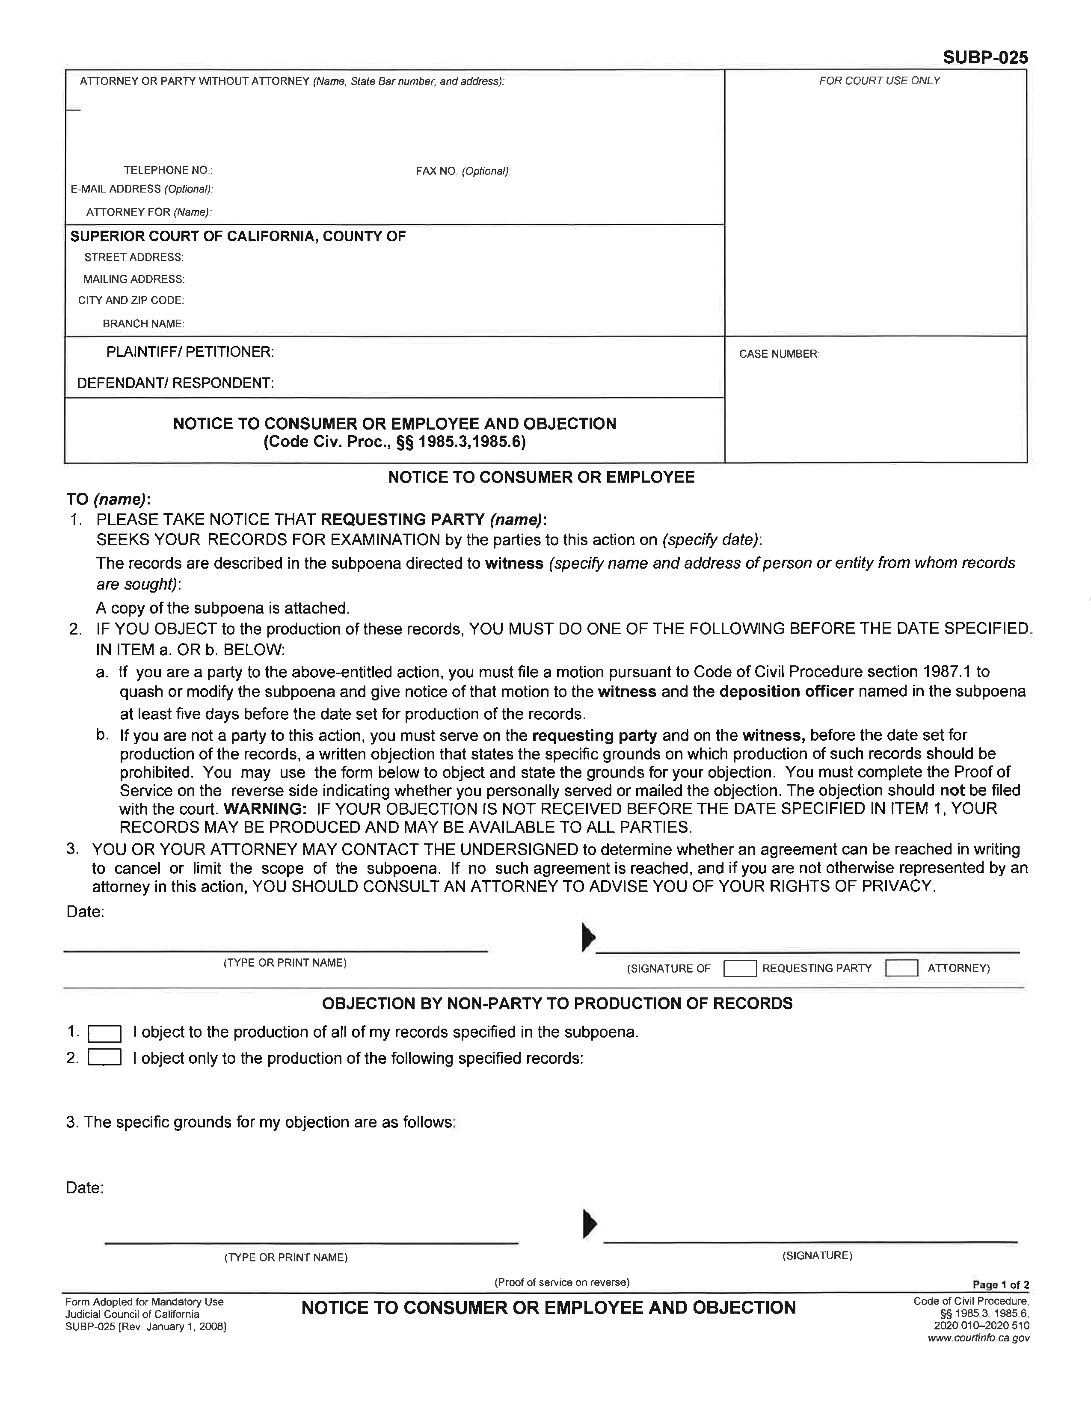

Maureen O’Connor SBN: 208781 c/o Axiom Requisition Copy Service
See Attached Addendum
Maureen O’Connor – SBN: 208781
c/o Axiom Requisition Copy Service, 2869 Jolly Road
Okemos, MI 48864
(877) 886-5090
(517) 886-4116
records@axiomcopy.com
ANTHONY CROCETTO a/k/a ANTHONY CROCELTO,
KYLE WASHINGTON and JEAN-RENEL MARQUIS,
ANTHONY CROCETTO a/k/a ANTHONY CROCELTO,
April Term 2015 01810
Luke Remwolt
Luke Remwolt
XXX
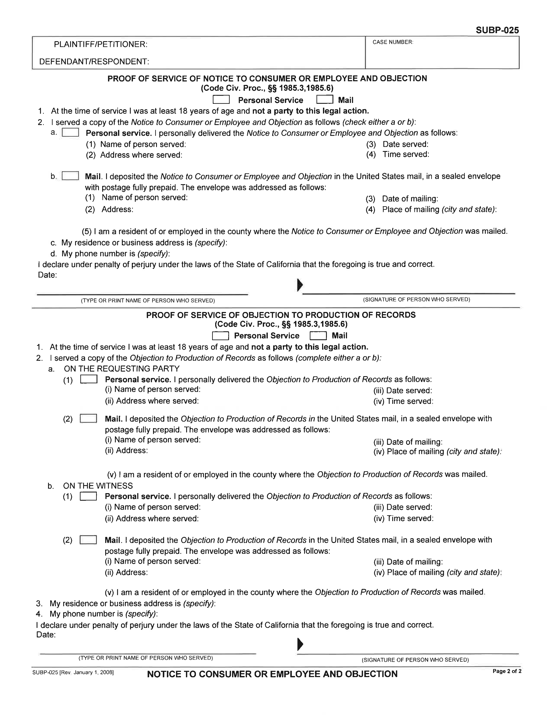

ADDENDUM

